**Hands On Assignment 1**

**Bhuvanesh P – MM19B027**

**1. Report the bond length of N2 and CO optimized by conjugate gradient method, as implemented in VASP.**

Equilibrium Distance for

* N2 - 1.11771017 A0
* CO2 - 1.14367915000002 A0

**2. Calculate energy when distance between N atoms and C and O atoms is changed by -5 pm and 5 pm, from equilibrium bond length (as calculated above).**

* The energy of N2 with (+5 and -5 pm) from equilibrium distance

-16.435743 eV and -16.384161 eV

* The energy of CO2 with (+5 and -5 pm) from equilibrium distance

-14.667137 eV and -14.633818 eV

**3. Fit energy as function of distance to a parabola and find the bond length. Attach the curve and the fitted equation.**

* For N2 the fitted equation and the curve are given below

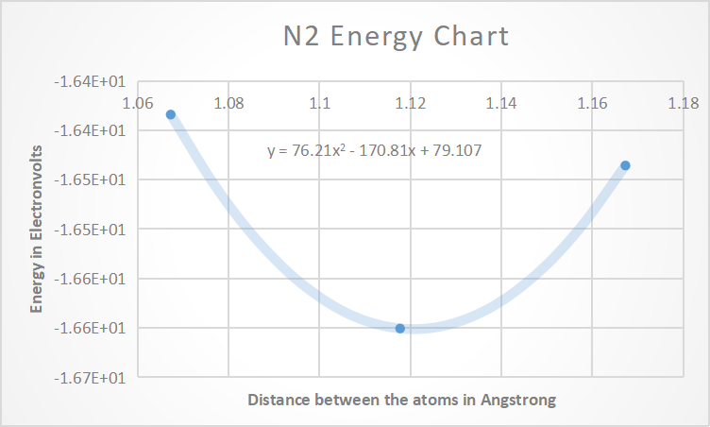

For the equation of the form ax2 + bx+ c, the minimum will occur at –b/2a which is obtained after differentiation

The equation fitted is y = 76.21x2 - 170.81x + 79.107

The minimum point = -(-170.81)/(2*76.21) = 1.12 A0 which is nearly equal to the equilibrium value of 1.117 A0

* For CO2 the fitted equation and the curve are given below

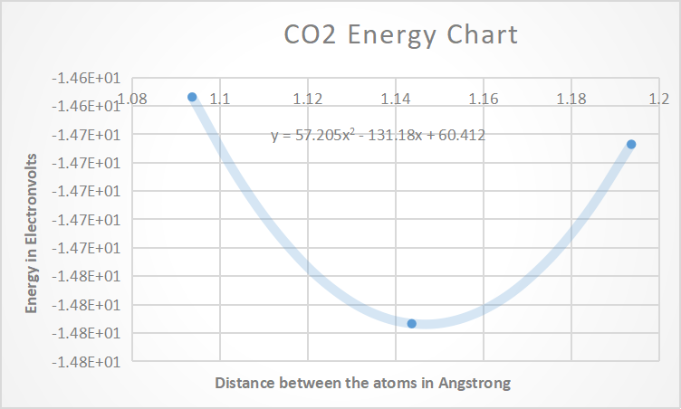

The equation fitted is y = 57.205x2 - 131.18x + 60.412

The minimum point = -(-131.18)/(2*57.205) = 1.146 A0 which is nearly equal to the equilibrium value of 1.144 A0